10/26/2024

FUNDAMETAL OF COMPUTER PROGRAMMING

LAB 7:

HANAN MAJEED

CMS ID:519166

TASK A:

Write a modular program that generates a diamond as shown in the output below based on an integer between 1-10 entered by the user. you should create a function called **diamond()** that takes an integer as an argument and displays the diamond on the screen.

|  |  |
| --- | --- |
|  |  |

INPUT:

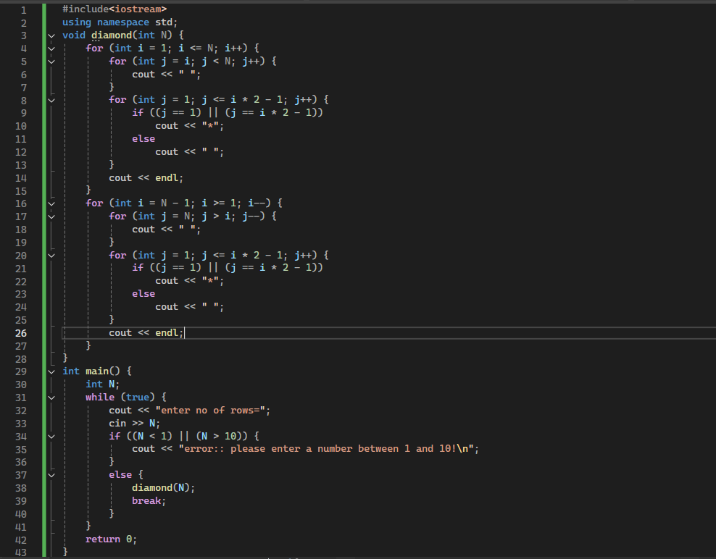

OUTPUT:

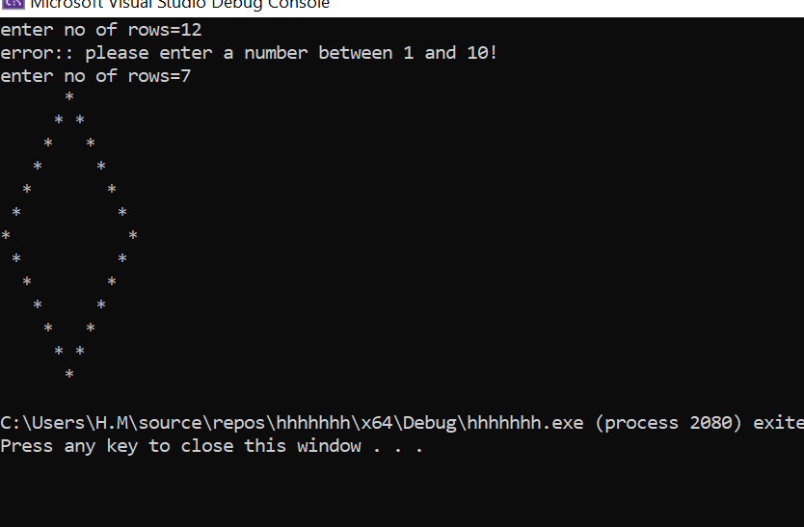

**Task B:**

Create a function called **next_prime()** that takes an integer as an argument and returns the next prime number. If the entered number is prime, return the next prime number. You should create another function called **is_prime()** to check if the number is prime or not. Use the next_prime() function in your main program to continuously get numbers from the user until the user enters 0, which will terminate the program. Show appropriate messages to the users.

A prime number is a whole number greater than 1 that cannot be exactly divided by any whole number other than itself and 1.

INPUT:

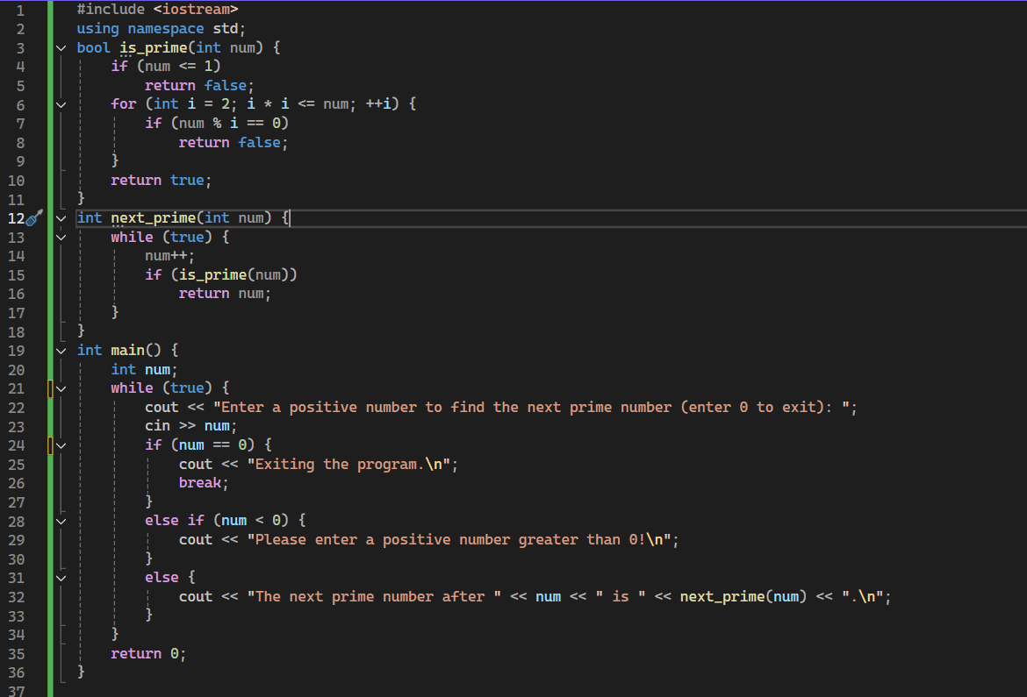

OUTPUT:

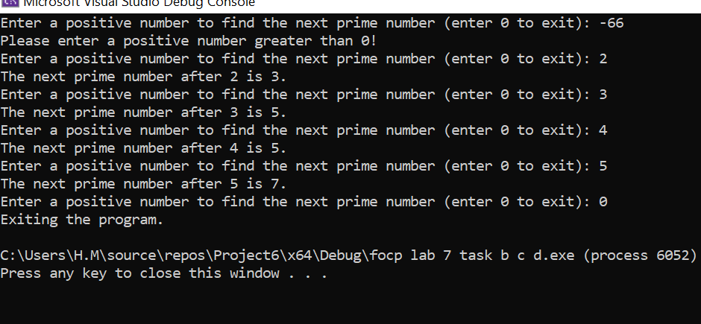

**Task C:**

Write a modular program to check whether a given number is a **strong number** or not. A number is considered a strong number if the sum of the factorials of its individual digits is equal to the original number entered by the user.

INPUT:

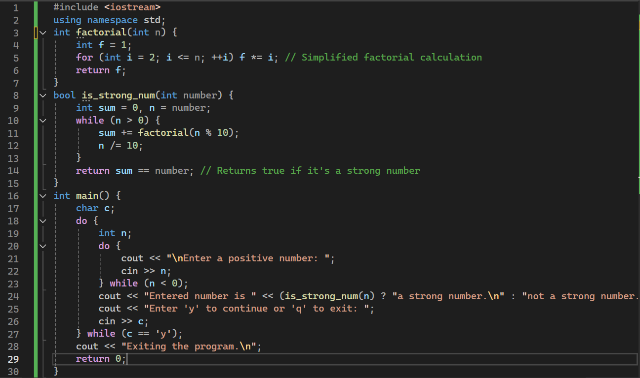

OUTPUT:

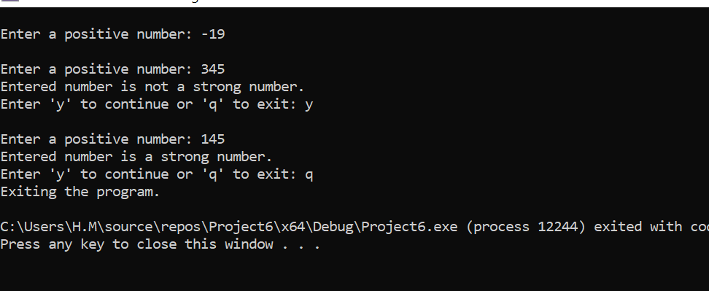

TASK D:

Create a function called **show_difference()**, that takes the length (L) and width (W) of the rectangle entered by the user and returns the difference of the areas of the circle and ellipse. You should create **one general function** inside the show_difference() function which will calculate the area of both the circle and the ellipse.

INPUT:

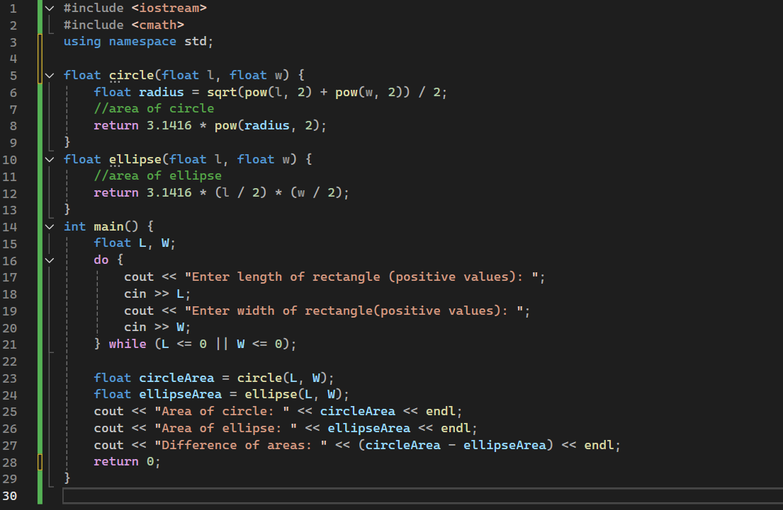

OUTPUT:

